Input:

<html>

    <head>

<script>

    function alertfun()

    {

        var name= prompt ("This is an alert Box", "Write here");

        if (name!= null && name!="")

        {

            document.write(name);

        }

    }

</script>

    </head>

    <body>

        <input type ="button" onclick="alertfun()" value="Click Here">

    </body>

</html>

Output:

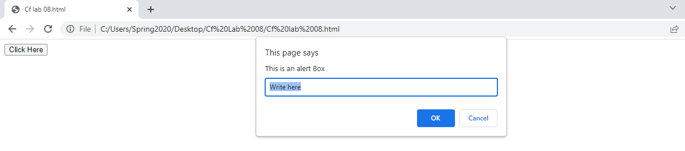

Task No 01: Create a Temperature converter using JavaScript.

Input:

Output:

Task No 02: Create a simple Calculator using Prompt Box. Take two inputs from User and ask the Operation they want to perform.

Input:

<html>

    <head>

        <script>

            const num1 = parseFloat(prompt('Enter First Number = '));

            const num2 = parseFloat(prompt('Enter Second Number = '));

            var op = prompt('Enter the operator ( +,-,\*,/) :');

            let result;

            if (op=='+')

            {

                result = num1 + num2;

            }

            else if (op == '-')

            {

                result = num1 - num2;

            }

            else if (op == '\*')

            {

                result = num1 \* num2;

            }

            else if (op == '/')

            {

                result = num1/num2;

            }

            document.write("Result of " +num1+ " "+op+ " "+num2+ " = "+result);

        </script>

    </head>

</html>

Output:

